RESTAURANT
RECOMMENDATIONS

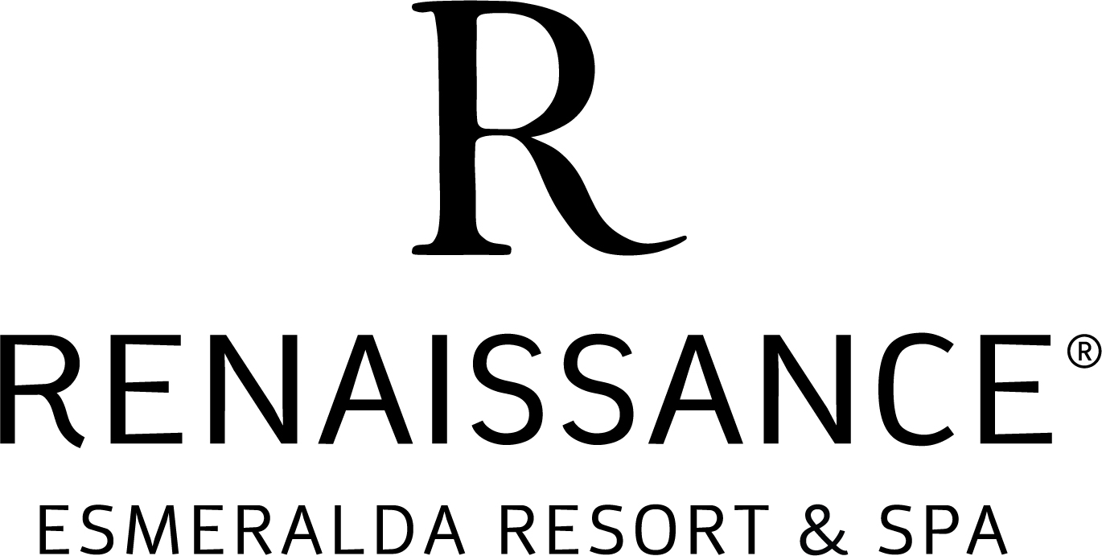

MEXICAN/SOUTHWEST

Armando’s 760.346.0744
73-260 El Paseo, Palm Desert

Don Diego’s 760.340.5588
74-969 Hwy 111, Indian Wells

Fresh Agave 760/836-9028
73-325 Hwy 111, Palm Desert

Las Casuelas Nuevas 760.328.8844
70-050 Hwy 111, Rancho Mirage

Restaurante Guillermo’s 760.341.0980
72-850 El Paseo, Palm Desert

Trattoria Mezzomondo 760.636.0507
73850 Hwy 111, Palm Desert

SEAFOOD

Mitch’s on El Paseo 760.779.9200
73-951 El Paseo, Palm Desert

Pacifica in the Desert 760.674.8666
73-505 El Paseo, Palm Desert
At the Gardens

Fisherman’s Market 760.777.1601
78-575 Hwy 111 #100, La Quinta

ISLAND TWIST

Tommy Bahama’s 760.836.0188
73-592 El Paseo, Palm Desert

STEAK

LG’s Prime Steak House 760.771.9911
78-525 Hwy 111, La Quinta

Mastro’s Steakhouse 760-776-6777
73-405 El Paseo, Palm Desert

Morton’s Steak House 760.340.6865
74-880 Country Club Drive, Palm Desert

Ruth’s Chris Steak House 760.779.1998
74-740 Hwy 111, Palm Desert

Sullivan’s Steakhouse 760.341.3560
73-505 El Paseo, Palm Desert

ITALIAN

Castelli’s 760.773.3365
73-098 Hwy 111, Palm Desert

Il Corso 760.341.6700
73-520 El Paseo, Palm Desert

La Spiga 760.340.9318
72-557 El Paseo, Palm Desert

Mimmo’s 760.346.9712
73-540 Hwy 111, Palm Desert

Ristorante Mamma Gina’s
760.568.9898
73-705 El Paseo, Palm Desert

Piero’s Pizza Vino 760.568.2525
73-222 El Paseo, Palm Desert

FRENCH

Café des Beaux-Arts 760.346.0669
73-640 El Paseo, Palm Desert

Chez Pierre Bistro 760.3461818
74-040 Hwy 111, Palm Desert

Cuistot 760.340.1000
72-595 El Paseo, Palm Desert

La Brasserie Bistro 760.771.4400
78-477 Hwy. 111, La Quinta

Le Paon 760.610.5320
73-399 El Paseo, Palm Desert

Deli

Sherman’s Deli 760.325.1199
73-161 Country Club Dr., Palm Desert

CALIFORNIA

Arnold Palmer’s 760.771.4653
78-164 Ave. 52, La Quinta

Cliffhouse 760.360.5991
78-250 Hwy 111, La Quinta

Cork & Fork 760.777.7555
47875 Caleo Bay, La Quinta

Eureka 760.834.7700
74-985 Hwy 111, Indian Wells

The Grill 760.777.7773
78-065 Main Street, La Quinta

Fortun’s Kitchen & Bar 760.564.8744
78085 Avenida La Fonda, La Quinta

Kaiser Grill 760.779.9888
74040 Hwy 111, Palm Desert

The Nest 760.346.2314
75-188 Hwy 111, Indian Wells

Vicky’s of Santa Fe 760.345.9770
45-100 Club Drive, Indian Wells

Vue Bar & Grill 760.834.3800
Indian Wells Golf Resort (Next Door)

Chinese

Cantón Bistró 760.771.9129
79-405 Hwy. 111, La Quinta

P.F Chang’s Bistró 760.776.4912
71-800 Hwy 111, Rancho Mirage

Japanese

Okura 760.564.5820
78-370 Hwy 111, La Quinta

Misaki 760/771-3570
46660 #1Washington, La Quinta

Venue Sushi Bar & Sake Lounge 760.346.1500
73-111 El Paseo, Palm Desert

Teppanyaki

Hibachi 760.674.0078
71-680 Hwy 111, Rancho Mirage

Kobe Steak House 760.324.1717
69-838 Hwy 111, Rancho Mirage

Shogun 760.346.1223
74-225Hwy 111, Palm Desert

Thai

Le Basil 760.773.1112
72-695 Hwy 111, Palm Desert

My Thai 760.564.8424
46600 Washington St, La Quinta

Thai Smile 760.341.6565
73-725 El Paseo, Palm Desert

FINE DINING

Cork Tree 760.779.0123
74-950 Country Club Dr., Palm Desert

Lavender Bistro 760.564.5353
78-073 Calle Barcelona, La Quinta

Jillian’s 760.776.8242
74-155 El Paseo, Palm Desert

Wally’s Desert Turtle 760.568.9321
71-775 Hwy 111, Rancho Mirage

